Resetting view in Outlook

In Outlook (classic), if you view is missing the preview pane, or the sizing is all wrong, resetting your view is a good way to try and fix this
Open outlook and go the view tab
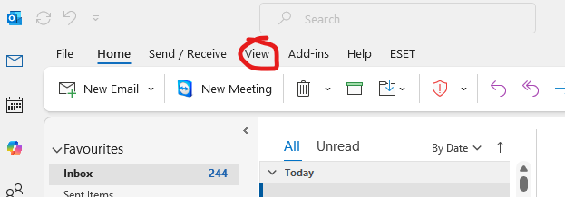

Click on the current view and reset view. This will reset the view to defaults
